**Project Initialization and Planning Phase**

| Date | 23 September 2024 |
| --- | --- |
| Team ID | LTVIP2024TMID24973 |
| Project Name | Detection of Phishing Websites from URLs Using Machine learning |
| Maximum Marks | 3 Marks |

**Define Problem Statements (Customer Problem Statement Template):**

The major trouble is that phishing technique is bad accuracy and low adaptability to new phishing links. We plan to apply machine learning to overcome these limitation through imposing some classification algorithms and evaluating the overall performance of these algorithms on our dataset. We have decided on the Random Forest method because of its excellent performance in classification but random forest and decision tree are not good with nlp data

**Example:**

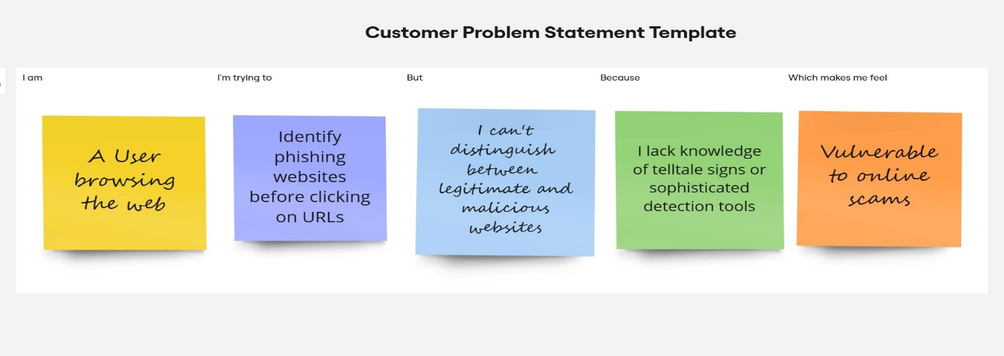

|  |  |  |  |  |  |
| --- | --- | --- | --- | --- | --- |
| **Problem**  **Statement (PS)** | **I am**  **(Customer)** | **I’m trying to** | **But** | **Because** | **Which makes me feel** |
| PS-1 | a cybersecurity analyst | protect my organization from phishing attacks. | many phishing websites closely mimic legitimate ones. | these attacks are becoming more sophisticated and difficult to identify. | overwhelmed and concerned about potential security breaches |